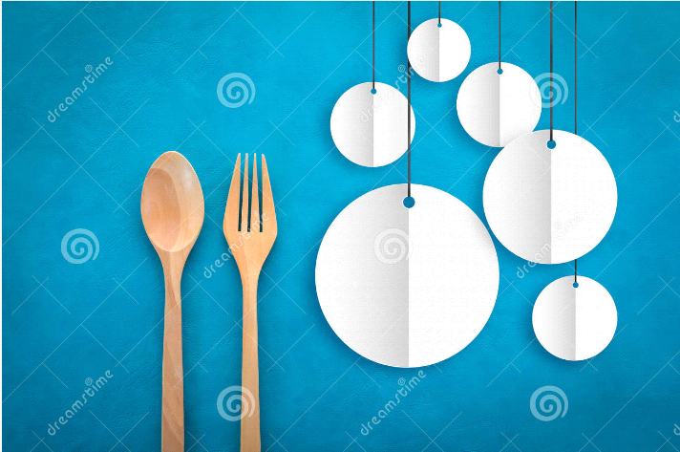

***Dish And The Spoon***

***Submitted To:Sakshi Sharma***

***Submitted By:* Jagdeep Sharma 1893739**

**Davinder Singh Kharoud 1893033**

**Vivek Kumar 1893481**

**Harkirat Singh 1895155**

**COVER PAGE ( )**

**1. Introduction**

**1.1 Purpose**

**1.2 Scope**

**2. General Description**

**2.1 Product Functions**

**2.2 User Characteristics**

**3. Analysis Models**

**3.1 Use Case Diagrams**

**3.2 Sequence Diagrams**

**3.3 Class Diagram**

**4. Screen Flow Diagram**

**4.1 View Hotels**

**4.2 Booking**

**4.3 Need Help**

**5.Reference**

1. **Introduction**

Our thoughts behind creating the application Dish And The Spoon is to make easier for the people to book seats and order food online at specific time.The system search the Restaurants according to filters chosen by customer example:distance,price etc and give them appropriate list. From which customer choose the restaurant and book seats and give food order within the application .people can contact admin for adding their restaurants

* 1. **Purpose**

Application with straight forward interface and high practical capacity to deal with vast customer requests under single bound together interface. Customers can book the seats and order food without wasting time in the ques in front of restaurants. System has a ability to cancel orders but conditions apply that if time passes more than 4 hours no money will be refunded else 50 percent payment will be given back. people can add their restaurants by contacting through app which will give good profit to application developer and restaurant owner.

* 1. **Scope**
* This application is named as Dish and the Spoon which can be accessed by customers directly from their smartphones or web.The proposed system is a software solution for users to easily book and take orders.
* The application is user friendly, handy and can be downloaded free from app store. Application also has a feature to sign up with Facebook,gmail,Twitter etc.Customers can view the whole list of restaurants according to their preference ,they select the restaurant ,order food and book seats. application also provide gift cards and special offers according to customer usage.If the customer is not satisfied or need any help they can contact us by the option "Need Help?" provided in the app.
* The description of app is below:

1. Customers can easily access the app from app store and restaurant owners can contact the admin to enjoy the services of app.
2. The admin board will give you tremendous alternatives to setup your app and providing you result according to filters.
3. The system is also free from risk of being intercepted by unauthorised person because before gaining access in the system it is required to login to the system by entering username and password.
4. Customers reserve the seats and order food without wasting time in ques.
5. In case of cancellation customer can cancel the booking directly through app but conditions apply that if customer cancel the order before 4 hours of order half of payment will be refunded else no money will be refunded.
6. This gives us the general photo of the stream of the application.

**2. General Description**

1. Customer can utilize this application for reserving seats and ordering food in advance before going to restaurant.while restaurant owners can promote and earn profit by signing up with this application.
2. Application is supported on Android,Ios and Windows.This also works fine with light processor but atleast 1GB RAM is recommended to run smoothly.
3. Application has a search filters as well as add to favourites option so that customers don't need to spend time in searching their favourites hotels.
4. Customers can earn giftcards by inviting other people or by booking different restaurants.They can provide Rating to the restaurants and comment so that other users can assume the restaurant service.
5. The app is recommended for the restaurants who are willing to earn more money and advertise their restaurant Customer can be anyone who are willing to pay for service and want to save time.They can do payment by credit or debit card online through secure firewalls.

**2.1 ADVANTAGES**

* This helps to reserve seats and order food easily through mobile application.
* It is much more efficient and faster than booking seats through browser in the restaurants.
* people do not need to stand in ques for long hours for booking ,they can book immediately.
* Through different search filters and special offers people can select appropriate restaurants for them.

**3. Analysis Model**

**3.1 Use Case Diagram**

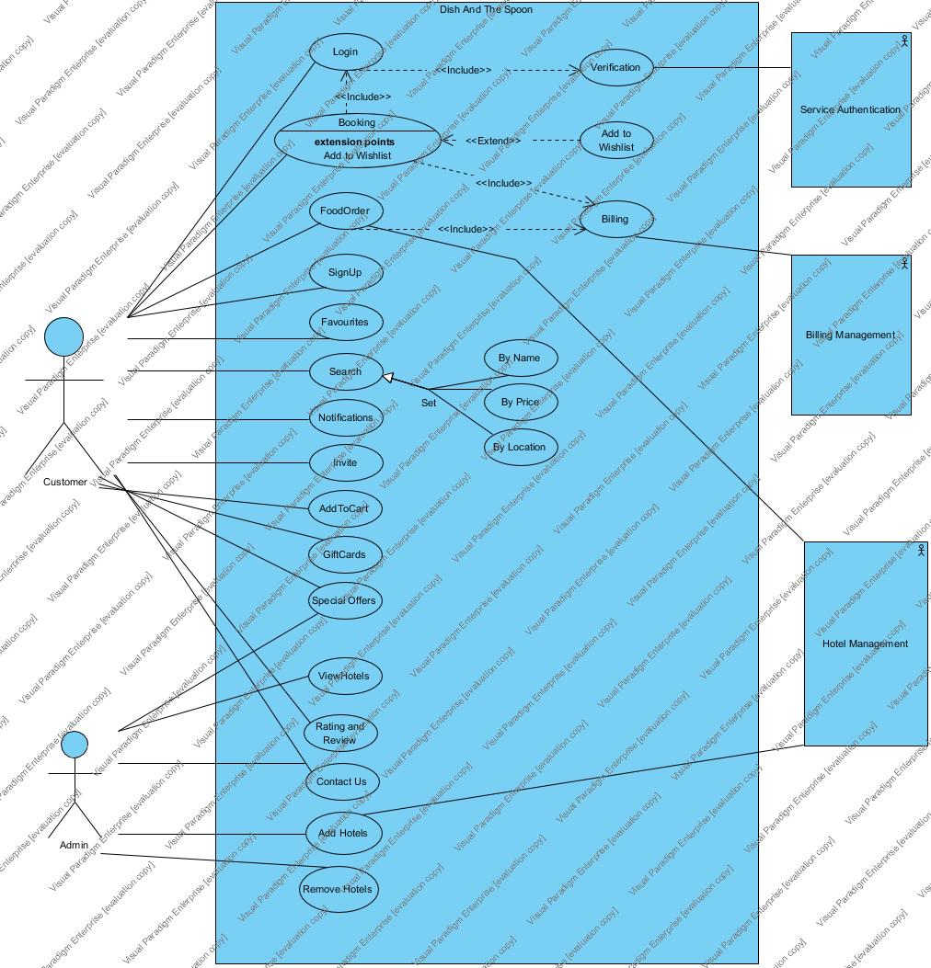

* 1. **Sequence Diagram**

**3.2.1 Login**

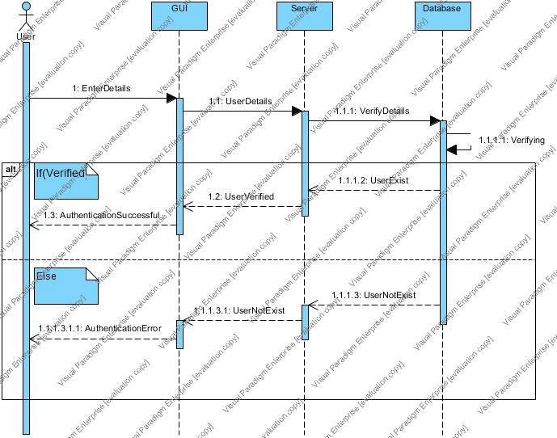

* + 1. **Booking Table Sequence Diagram**

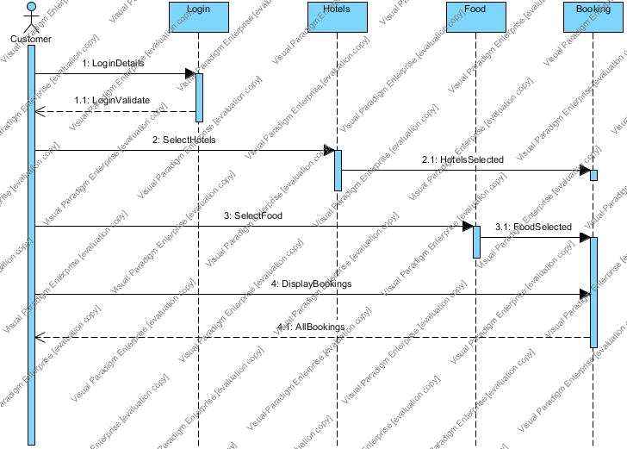

* + 1. **Search Sequence Diagram:**

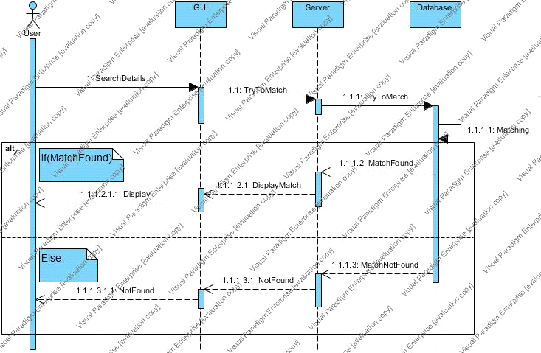

* + 1. **Payments Sequence Diagram**

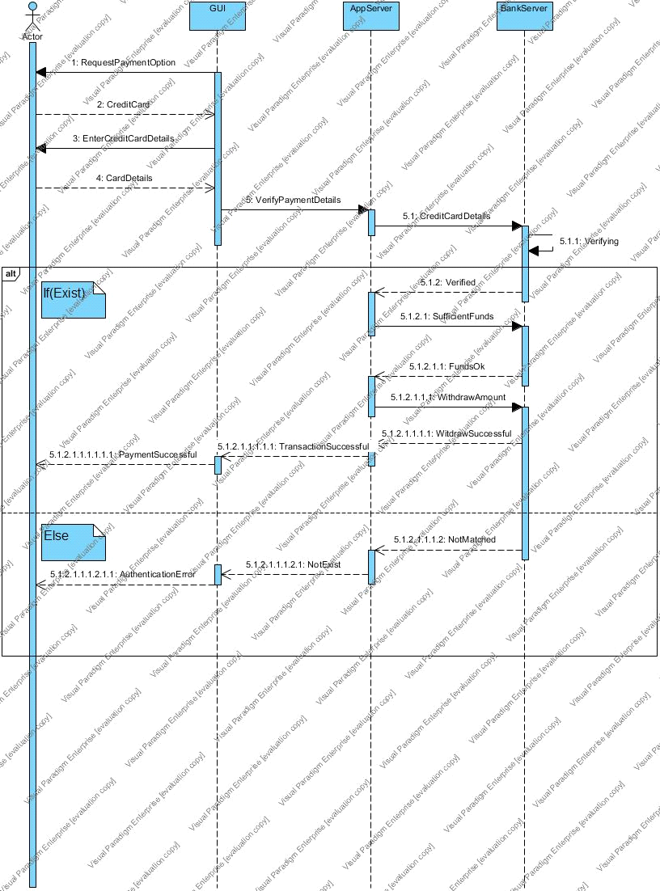

* 1. **Class Diagram**

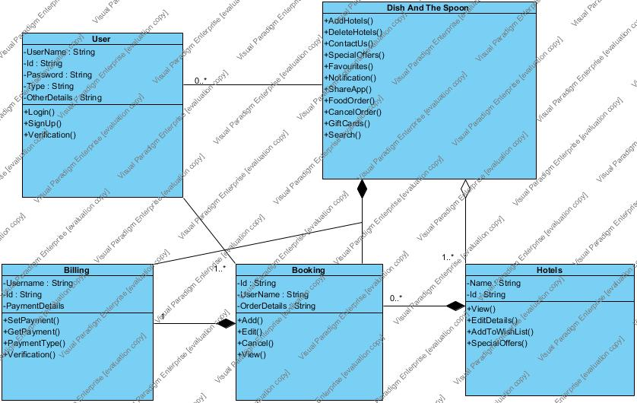

1. **Screen Flow Diagram**
   1. **View Hotels**

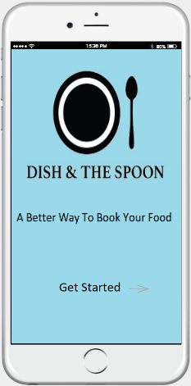 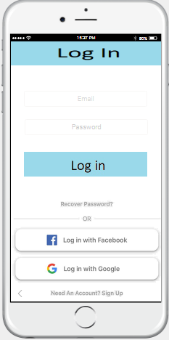 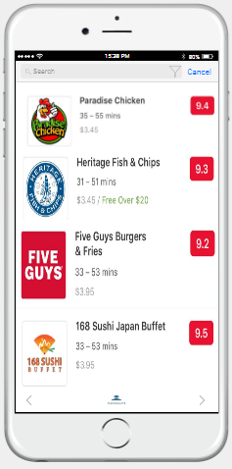

**4.2 Booking**

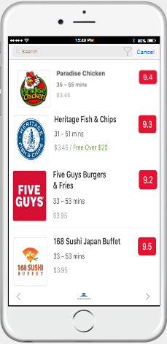 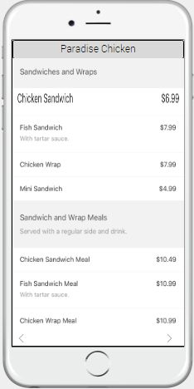 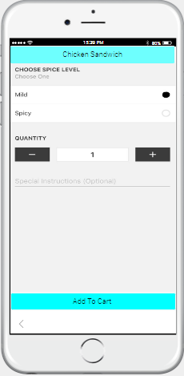

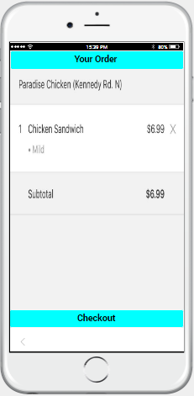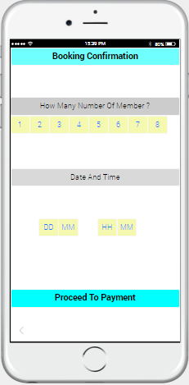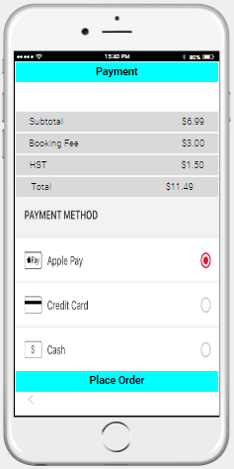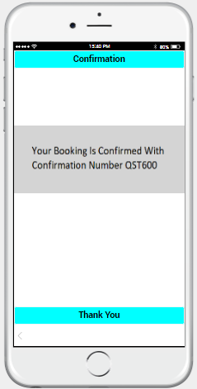

* 1. **Need Help**

 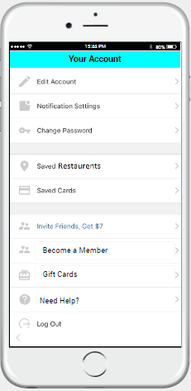 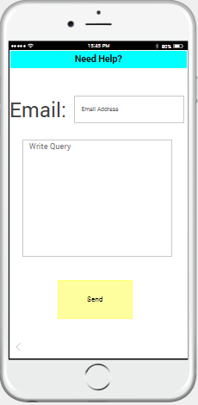

**.**

1. **Reference :**

https://github.com/DavinderSinghKharoud/Dish-And-The-Spoon.git